Record of Existing Injuries
Please complete and email to your child’s room for each new injury Sept 2023
Name of child:
Today’s date:
Date injury occurred:
Name of person informing the setting:
Relationship of person to the child:
Name of setting staff member being informed:
How did the injury happen?

Are there any visible marks, bruises or injuries (describe size, shape, colour and location)?

Was treatment given?

Was medical advice sought (include GP Surgery or hospital details)?

Additional information or comments:

Signature of person providing the
information:
Staff member’s signature: | To be completed by nursery
Date and time:
Staff member - remember to complete the ‘Existing injury follow up form’ if further information is required
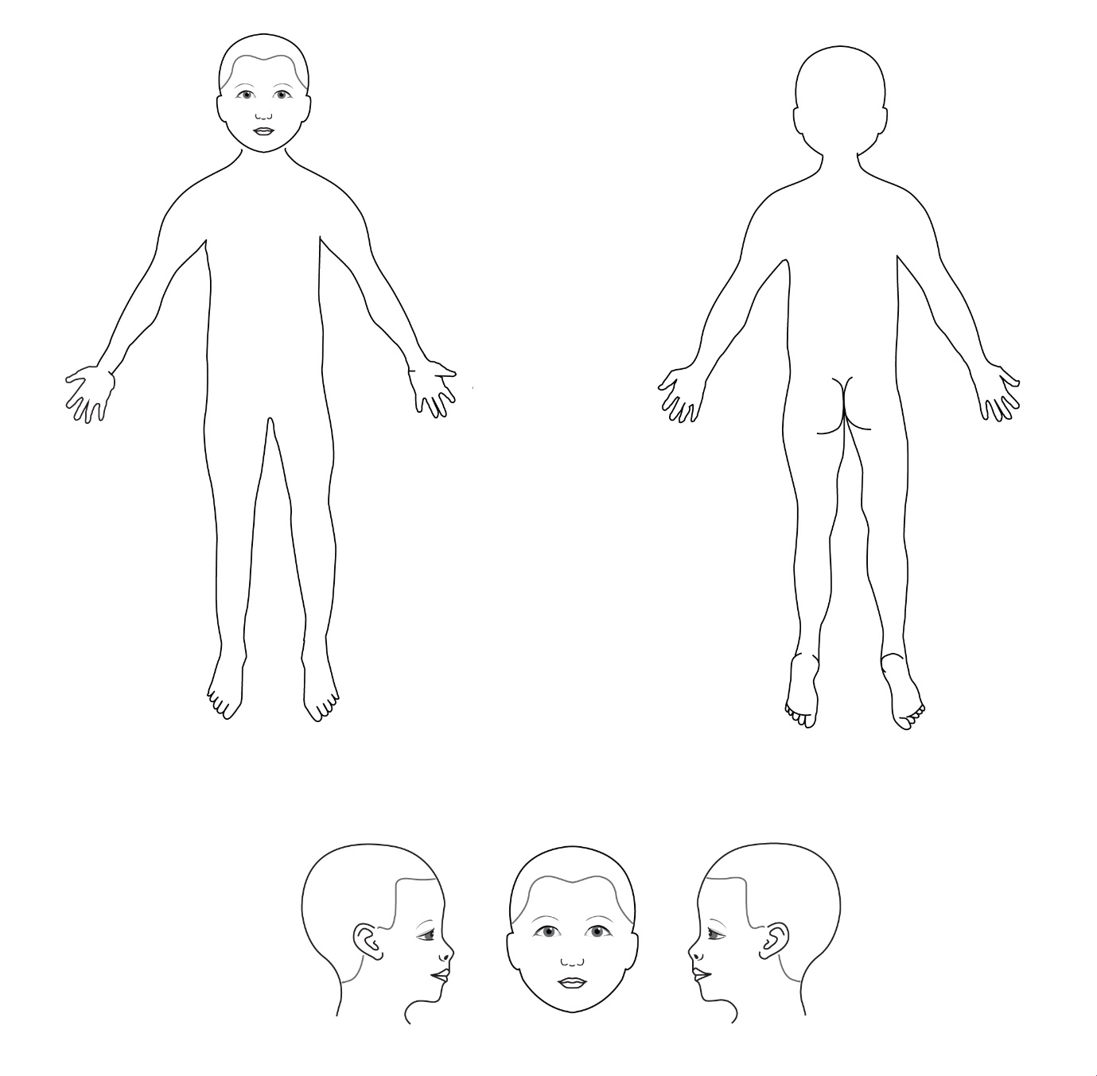

Use drawing tool to show injury location

